**ENGR 340-Introduction to Environmental engineering**

To: Deborah Sills

From: Loujin Daher

Date: September 17, 2013

Re: Nonlinear Curve Fitting

**Objective:**

The objective of this lab is to learn creating a high quality graphs using Kaleidagraph. Also, analyze the data and fitted models presented in these graphs.

**Part I:**

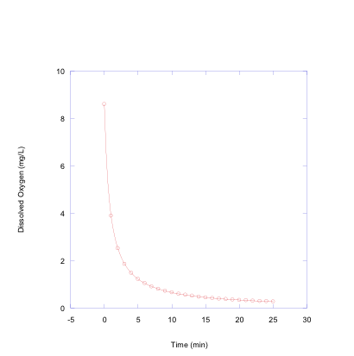

Figure 1. Measured dissolved oxygen in mg/L over time in minutes fitted in a Second Order Reaction, with Reaction Rate Coefficient (k) = 0.14 $\frac{L}{mg*min}$.

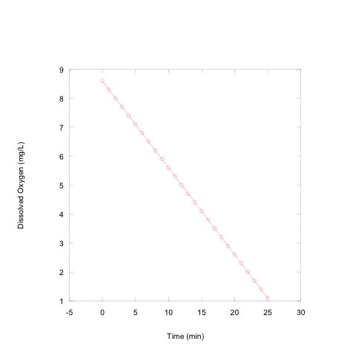

Figure 2. Measured Dissolved Oxygen in mg/L over time in minutes fitted in a Zero Order Reaction, with Reaction Rate Coefficient (k) = 0.3 $\frac{mg}{L*min}$.

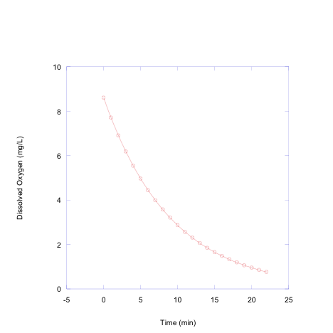

Figure 3. Measured Dissolved Oxygen in mg/L over time in minutes fitted in a First Order Reaction, with Reaction Rate Coefficient (k) = 0.11 $\frac{1}{min}$.